Clinical Rationale for SARS-CoV-2 Base Spike Protein Detoxification in Post COVID-19 and Vaccine Injury Syndromes

Peter A. McCullough, M.D., M.P.H., Cade Wynn, Brian C. Procter, M.D.

Abstract
The spike protein is responsible for the pathogenicity of the SARS-CoV-2 infection and drives the development of adverse events, injuries, disabilities, and death after vaccination through immunologic and thrombotic mechanisms. The long-lasting spike protein has been found in the brain, heart, liver, kidneys, ovaries, testicles and other vital organs at autopsy in cases of death after vaccination. In the case of vaccine-induced thrombotic injury, the spike protein has been found within the blood clot itself. Thus, there is strong rationale for considering residual SARS-CoV-2 spike protein as a treatment target in post COVID-19 and vaccine injury syndromes. The spike protein participates directly in pathophysiology, incites inflammation, and propels thrombosis. While specific syndromes (cardiovascular, neurological, endocrine, thrombotic, immunological) will require additional therapies, we propose the clinical rationale for a base detoxification regimen of oral nattokinase, bromelain, and curcumin for patients with post-acute sequalae from SARS-CoV-2 infection and COVID-19 vaccination. The empiric regimen below can be continued for 3-12 months or more and be guided by clinical parameters:
-Nattokinase 2000 FU (100) mg orally twice a day without food
-Bromelain 500 mg orally once a day without food
-Curcumin 500 mg orally twice a day (nano, liposomal, or with piperine additive suggested)
No therapeutic claims can be made for this regimen because it has not been tested in large, prospective, double-blind, placebo controlled randomized trials. No such studies are planned or funded currently by federal or institutional sponsors. The main caveats are bleeding and allergic reactions. The regimen can be used in addition to antiplatelet and antithrombic agents, however, caution is advised with respect to monitoring bleeding risks.

SARS-CoV-2 Spike Protein as a Therapeutic Target

The majority of the global population has contracted COVID-19 and/or taken one of the many COVID-19 vaccines. As a result, the injurious SARS-CoV-2 spike protein has been an antigenic exposure to most in the world. Provided the infection was treated early and limited to the nasopharynx without invasive disease, the infection was self-limited without sequelae. Mucosal immunity with IgA, T-cells, B-cells, and natural killer cells handles the coronavirus and defends the body against systemic illness. [1] However, in the setting of invasive disease with COVID-19 pneumonia, viremia, cytokine storm, thrombosis, and end-organ injury, there is evidence of widespread residual replicating SARS-CoV-2 spike protein in tissues for months, and the S1 segment within CD16 monocytes for more than one year. [2]
Repeated administrations of COVID-19 vaccines, particularly the mRNA or adenoviral DNA products, deliver the genetic code for the spike protein, which is produced by a wide array of cells in tissues, resulting in an uncontrolled duration and cumulative doses of spike protein. The rise in IgG against the spike protein is many fold greater after vaccination than from the natural infection. This is a proxy for considerably greater exposure to the spike protein after immunization than after infection. Anti-spike IgG levels are associated with post-COVID-19 symptoms. [3] Yonker et al. have recently shown that some individuals do not develop neutralizing antibodies against the spike protein, and as a result develop organ injury, particularly myocarditis in children and young adults. [4] Free circulating soluble and extracellular vesicle-linked spike protein is associated with persistent symptoms. [5]
The spike protein is responsible for the pathogenicity of the SARS-CoV-2 infection and drives the development of adverse events, injuries, disabilities, and death after vaccination through immunologic and thrombotic mechanisms. The spike protein has been found in the brain, heart, liver, kidneys, ovaries, testicles and other vital organs at autopsy in cases of death after vaccination. [6-9] In the case of vaccine-induced thrombotic injury, the spike protein has been found within the blood clot itself. [10]
Thus, there is strong rationale for considering residual SARS-CoV-2 spike protein as a treatment target in post COVID-19 and vaccine injury syndromes. The spike protein participates directly in pathophysiology, incites inflammation, and propels thrombosis. Thus, overlapping coverage for these domains would be desirable in a combination approach. While specific syndromes (cardiovascular, neurological, endocrine, thrombotic, immunological) will require additional therapies, we will focus the remaining discussion on degrading the spike protein and antagonizing its effects in tissues and organs.

Proteolytic Degradation of Spike Protein

Nattokinase
The spike protein has been found free, bound by antibodies, and also encased within lysosomes or exosomes both inside and outside of cells. Patterson et al. have found these, both after infection and after vaccination, likely worsened by repeated exposures (Figure 1). This shows that the spike protein can persist in the human body for a very long time (months to years), probably because it is resistant to proteolytic cleavage and disposal. [11]
Proteolytic cleavage of spike appears to be an important mechanism to initiate clearance of the protein by the reticuloendothelial system. Nattokinase is a naturally occurring proteolytic enzyme with thrombolytic properties derived from the fermentation of soy beans by Bacillus subtilis natto. [12] The organism is a probiotic gram-positive spore-forming bacterium with veterinary and human applications. [13] Nattokinase has been widely used as a cardiovascular supplement in Japan for its anti-atherosclerotic and antithrombotic properties. [14] It has undergone safety testing in doses up to 80,000 fibrinolytic units (FU) daily. Kurosawa and colleagues have shown in humans that D-dimer concentrations at six and eight 8 hours, and blood fibrin/fibrinogen degradation products at four hours after administration of a single oral dose of 2,000 FU (100 mg) were elevated significantly (p < 0.05, respectively). Thus, an empiric starting dose could be 2,000 FU twice a day. Full pharmacokinetic and pharmacodynamic studies have not been completed, but several years of market use as an over-the-counter supplement suggests that nattokinase is safe, with the main caveat being excessive bleeding. Caution is needed with concurrent antiplatelet and anticoagulant drugs. [15]
Oba and colleagues performed a series of experiments with various concentrations of nattokinase in preclinical models. They found that nattokinase effectively stopped SARS-CoV-2 and bovine herpes virus type 1 infection of human cells in culture, and that the proteolytic effect of nattokinase was heat sensitive. [16] Tanikawa et al. examined the effect of nattokinase on the spike protein of SARS-CoV-2. In the first experiment they demonstrated that spike was degraded in a time and dose-dependent manner in a cell lysate preparation. that could be analogous to a vaccine recipient. The second experiment demonstrated that nattokinase degraded the spike protein in SARS-CoV-2-infected cells. This reproduced a similar study done by Oba and colleagues. [17] Because of the risk of bleeding, patients must be strongly cautioned to seek medical supervision with combining this nutraceutical with concurrent antiplatelet and anticoagulant drugs. Additionally, allergic reactions can occur, especially in patients who have known soy allergies. There is insufficient information for the use of nattokinase in children or pregnant or lactating women.

Bromelain
Bromelain is a family of cysteine proteases, isolated from the pineapple stem (Ananas comosus). [18] Traditionally, it has been used for its antiinflammatory and healing effects in cases of arthritis and injury, while it has been approved in Europe for the debridement of burn wounds. Experimental studies have demonstrated that bromelain presents unique immunomodulatory actions: 1) downregulation of the proinflammatory prostaglandin PGE-2 through inhibition of NF-kB and cyclooxygenase 2 (COX-2); 2) upregulation of the antiinflammatory PGE-1 (Figure 1); 3) activation of inflammatory mediators (interleukin 1b, interleukin-6, tumor necrosis factor-a, and interferon-g) as an acute response to cellular stress, but also inhibition of inflammatory mediators in states of overt cytokine production; 4) modulation of T-cell responses in vitro and in vivo; and 5) enhancement of T-cell dependent antigen-specific B-cell antibody responses.
Importantly, bromelain exerts dose-dependent anticoagulant effects: 1) downregulation of PGE-2 and thromboxane A2 (TXA2), thus leading to relative excess of prostacyclin in platelets, and 2) promotion of fibrinolysis by stimulating the conversion of plasminogen to plasmin and prevention of platelet aggregation (Figure 1).
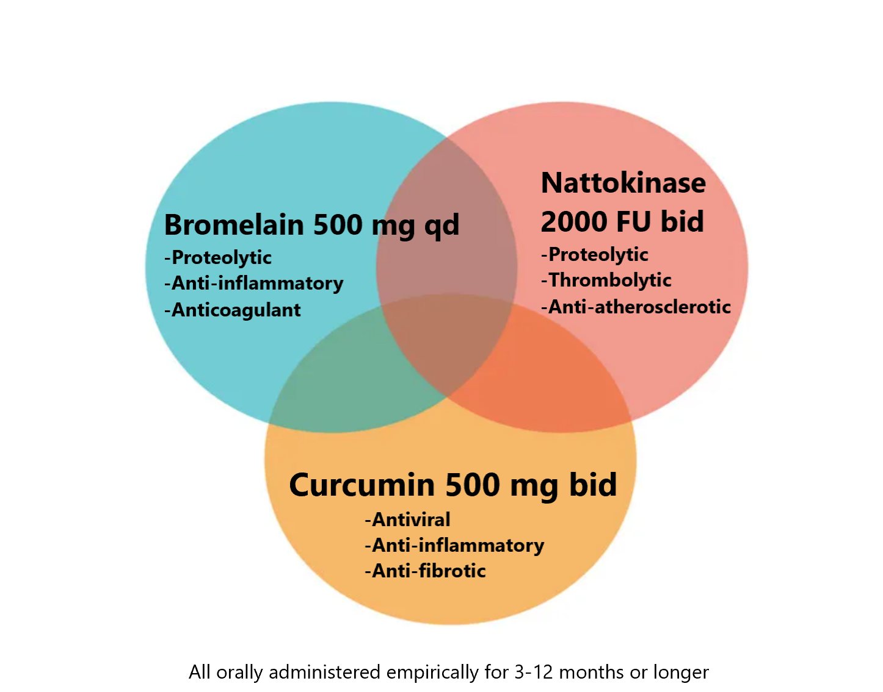

Figure 1. Venn Diagram of Mechanisms of Action of Proposed Agents that Target the SARS-CoV-2 Spike Protein

Bromelain also hydrolyzes bradykinin and reduces kininogen and bradykinin levels in serum and tissues, improving inflammation and edema as shown in animal studies. [19] Notably, the latter action supports a potential role of bromelain in alleviating COVID-19 symptoms such as cough, fever, and pain, and the more serious implications of inflammation, thrombosis, and edema. The effect of bromelain on PGE-2 inhibition exceeds that of prednisone and aspirin, presenting very low toxicity and no major side effects.
Additionally, a recent experimental study demonstrated that bromelain inhibits infection of VeroE6 cells by SARS-CoV-2 through blocking the virus binding and entry into cells by downregulation of ACE-2 and TMPRSS2 expression, and cleavage of the SARS-CoV-2 spike protein, presenting a novel and promising therapeutic option, which warrants further investigation. [20]
Bromelain increases the prothrombin time and partial thromboplastin time and can thus increase bleeding risk. It can cause gastrointestinal upset. Severe allergic reactions can occur. [21] Bromelain may increase the absorption of medications—including antibiotics (such as tetracycline and amoxicillin), chemotherapeutic agents (such as 5-fluorouracil and vincristine), ACE inhibitors (such as captopril and lisinopril), benzodiazepines, certain antidepressants, opioids, and barbiturates. Physician supervision is advised. A standard dose of bromelain for human use is 500 mg orally per day.

Inhibition of Spike and Its Fragments in Tissues

Curcumin
Curcumin (diferuloylmethane) is derived from turmeric (Curcuma longa), a member of the ginger family of plants. Curcumin is a polyphenol and modulates inflammation in the setting of viral infections via inhibition of cytokines through multiple transcription factors. Additionally, curcumin inhibits angiotensin converting enzyme (ACE), modulating angiotensin II synthesis, and promotes fibrinolysis and the anticoagulation process (see Figures 1 and 2).
The antiviral actions of curcumin against multiple viruses (influenza and hepatitis viruses, herpes viruses, human papilloma virus, human immunodeficiency virus, severe acute respiratory syndrome coronavirus and other coronaviruses), bacteria, and fungi have been suggested in prior mechanistic studies. [22] In silico studies have demonstrated that curcumin prevents SARS-CoV-2 entry into cells by blocking the spike protein binding sites and the cell ligands (ACE-2 receptors and TMPRSS-2), and by that mechanism reduces viral replication. [23]
The minimal absorption of curcumin following oral administration has been overcome with nanoparticle technology. Randomized trials have consistently showed reductions in hs-CRP and other inflammatory markers in the setting of spike protein mediated infection/injury. [24,25] The World Health Organization (WHO) has determined 0–3 mg per kilogram of body weight to be an acceptable daily dietary intake, about 250 mg. At higher therapeutic doses there can be gastrointestinal adverse events including peptic ulcer disease. Nano or liposomal curcumin is available as an oral supplement with better absorption dosed at 500 mg twice a day and has been shown to be safe without liver or serious gastrointestinal toxicity. [26] Alternatively, curcumin can be combined with piperine (black pepper extract), at about 10 mg/1000 mg, to significantly increase absorption. There are, however, published studies showing that curcumin supplements decrease effectiveness of prescription hormones thyroid and estradiol, so patients on these prescription medicines need to be monitored by their physicians to avoid being destabilized by the addition of curcumin. The same caution applies to turmeric supplements.
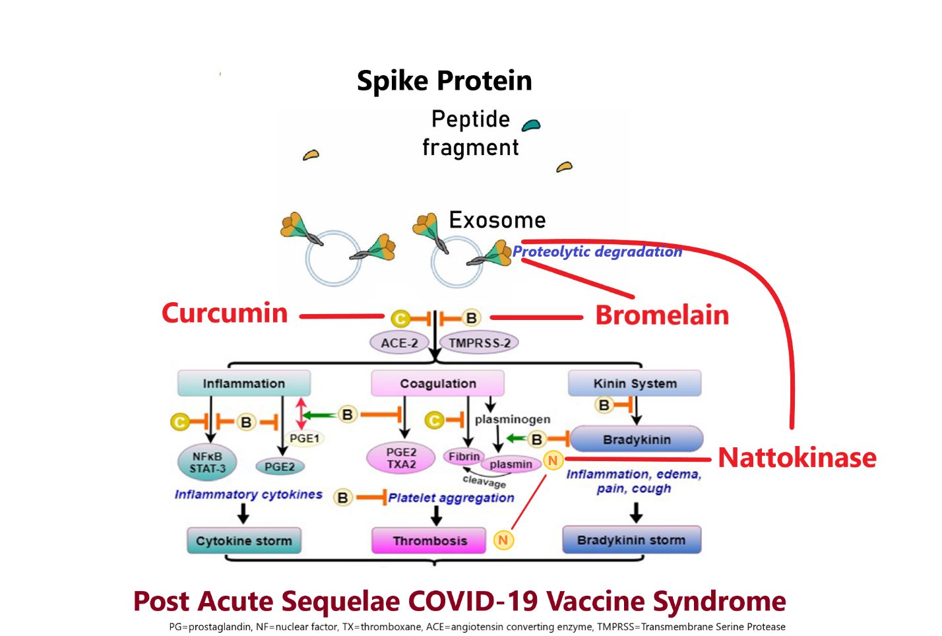

Figure 2. Sites of Possible Suppression of Spike-Protein Sequelae Including Degradation and Inhibition of Thrombosis and Inflammation

Other Compounds
There is a host of other compounds that have supportive mechanistic and clinical data that could additionally play roles in a multidrug regimen. A notable supplement is augmented N-acetylcysteine, which can be given in a dose range of 400 to 1,000 mg per day. Other hopeful products in a long list include: ivermectin, hydroxychloroquine, selenium, Irish sea moss, green tea extract (Camillia sinensis), Nigella sativa (black cumin), dandelion extract (Taraxacum officinale), glutathione, and many more. We have chosen to focus on nattokinase, bromelain, and curcumin as a manageable triad that has a well -characterized safety profile and sufficient information on dosing in clinical practice.

Laboratory and Clinical Monitoring

Laboratory monitoring can be helpful in guiding the response to treatment. A reasonable battery of commercially available assays above and beyond routine testing can include: hs-CRP, D-dimer, antinuclear antibody (ANA), qualitative antibodies for the SARS-CoV-2 nucleocapsid, and quantitative antibodies for the spike protein. Advanced panels at baseline and after treatment can be extended to reflect cytokines including: cytokines TNF-alpha, IL-4, IL-13, IL-2, GM-CSF, sCD40L, CCL5 (RANTES), CCL3 (MIP-1alpha), IL-6, IL-10, IFN-gamma, VEGF, IL-8, CCL4(MIP-1beta). Cellular measurements include WBC CD4%, CD8%, and CD4/CD8 ratio, and quantification of SARS-CoV-2 S1 spike protein-containing monocytes, available from Radiance Diagnostics, Naperville, Ill. [27]

Discussion

Triple therapy with nattokinase, bromelain, and curcumin is a generally safe detoxification foundation upon which other drug and nutraceutical treatment strategies can be developed for the amelioration of SARS-CoV-2 spike protein-driven syndromes affecting those who have recovered from COVID-19 and/or received one or more injections of a COVID vaccine (Figure 2). Unfortunately, most individuals around the globe have had both exposures and with multiple occurrences.
The duration of therapy and the impact on clinical outcomes such as quality of life, symptom scores, hospitalization, and death are unknown. Thus, no therapeutic claims can be made until large prospective randomized double-blind placebo-controlled trials are completed. A check of clinicaltrials.gov indicates that no such trials yet have been registered. In the meantime, based on signals of benefit and acceptable safety, the triad of nattokinase 2,000 FU (100 mg) twice daily, bromelain 500 mg a day, and nano-curcumin 500 mg twice daily for at least 3 months with continuation for a year or more, as a base detoxification regimen upon which additional agents can be added, is a reasonable empiric strategy for those suffering with post COVID-19 or vaccine-associated symptoms. Clinicians should recognize this combination has significant anticoagulant effects that will be potentially counterbalanced by the pro-coagulant effects of spike protein. Patients should be counseled and monitored for bleeding complications including easy bruising, nasal mucosal bleeding, and gastrointestinal hemorrhage.

Conclusion

Chronic disabling symptoms from “long COVID” and following mRNA injections are an increasingly prevalent problem. The symptomatic presentation has many common features, which might be explained by the spike protein of the virus, which is also manufactured by the vaccinee’s own cells. There is no accepted protocol for treatment. Based on their mechanisms of action, a combination of nattokinase, bromelain, and curcumin should be considered. Patients need close monitoring because of anticoagulant effects. Formal clinical trials are urgently needed.

Peter A. McCullough, M.D., M.P.H., an internist and cardiologist, is president of the McCullough Foundation; Cade Wynn works as an assistant with McKinney Family Medicine; Brian C. Procter, M.D., founder of McKinney Family Medicine, is a family physician practicing in McKinney, Texas. Contact: peteramccullough@gmail.com.

Disclosures: Dr. McCullough receives partial salary support and holds an equity position in The Wellness Company, Boca Raton, Fla. The Wellness Company markets dietary supplements, including Spike Support, which contains nattokinase among multiple ingredients.

REFERENCES

Fraser R, Orta-Resendiz A, Mazein A, Dockrell DH. Upper respiratory tract mucosal immunity for SARS-CoV-2 vaccines. Trends Mol Med 2023;29:255-267.
Patterson BK, Francisco EB, Yogendra R, et al. Persistence of SARS CoV-2 S1 protein in CD16+ monocytes in post-acute sequelae of COVID-19 (PASC) up to 15 months post-infection. Front Immunol 2022;12:746.
Joung S, Weber B, Wu M, et al. Serological response to vaccination in post-acute sequelae of COVID. BMC Infect Dis 2023;23:97.
Yonker LM, Swank Z, Bartsch YC, et al. Circulating spike protein detected in post-COVID-19 mRNA vaccine myocarditis. Circulation 2023;147:867-876.
Craddock V, Mahajan A, Spikes L, et al. Persistent circulation of soluble and extracellular vesicle-linked spike protein in individuals with postacute sequelae of COVID-19. J Med Virol 2023;95:e28568.
Nushida H, Ito A, Kurata H, et al. A case of fatal multi-organ inflammation following COVID-19 vaccination. Leg Med (Tokyo) 2023;63:102244.
Geeraerts T, Guilbeau-Frugier C, Garcia C, et al. Immunohistologic features of cerebral venous thrombosis due to vaccine-induced immune thrombotic thrombocytopenia. Neurol Neuroimmunol Neuroinflamm 2023;10:e200127.
Mörz M. A case report: Multifocal necrotizing encephalitis and myocarditis after BNT162b2 mRNA vaccination against COVID-19. Vaccines (Basel) 2022;10:1651.
Seneff S, Kyriakopoulos AM, Nigh G, McCullough PA. a potential role of the spike protein in neurodegenerative diseases: a narrative review. Cureus 2023;15:e34872.
De Michele M, d'Amati G, Leopizzi M, et al. Evidence of SARS-CoV-2 spike protein on retrieved thrombi from COVID-19 patients. J Hematol Oncol 2022;15:108.
Patterson BK, Francisco EB, Yogendra R, et al. SARS-CoV-2 S1 protein persistence in SARS-CoV-2 negative post-vaccination individuals with long COVID/ PASC-like symptoms. Research Square; 2022. doi: 10.21203/rs.3.rs-1844677/v1.
Sheng Y, Yang J, Wang C, Sun X, Yan L. Microbial nattokinase: from synthesis to potential application. Food Funct 2023;14:2568-2585.
Sun P, Wang JQ, Zhang HT. Effects of Bacillus subtilis natto on performance and immune function of preweaning calves. J Dairy Sci 2010;93:5851-5855.
Dabbagh F, Negahdaripour M, Berenjian A, et al. Nattokinase: production and application. Appl Microbiol Biotechnol 2014;98:9199-9206.
Kurosawa Y, Nirengi S, Homma T, et al. A single dose of oral nattokinase potentiates thrombolysis and anti-coagulation profiles. Sci Rep. 2015;5:11601.
Oba M, Rongduo W, Saito A, et al. Natto extract, a Japanese fermented soybean food, directly inhibits viral infections including SARS-CoV-2 in vitro. Biochem Biophys Res Commun 2021;570:21-25.
Tanikawa T, Kiba Y, Yu J, et al. Degradative effect of nattokinase on spike protein of SARS-CoV-2. Molecules 2022;27:5405.
Rowan AD, Buttle DJ, Barrett AJ. The cysteine proteinases of the pineapple plant. Biochem J 1990;266:869-875.
Lotz-Winter H. On the pharmacology of bromelain: an update with special regard to animal studies on dose-dependent effects. Planta Med 1990;56:249e53.
Kritis P, Karampela I, Kokoris S, Dalamaga M. The combination of bromelain and curcumin as an immune-boosting nutraceutical in the prevention of severe COVID-19. Metabol Open 2020;8:100066.
Chakraborty AJ, Mitra S, Tallei TE, et al. Bromelain a potential bioactive compound: a comprehensive overview from a pharmacological perspective. Life (Basel) 2021;11:317.
Praditya D, Kirchhoff L, Brüning J, et al. Anti-infective properties of the golden spice curcumin. Front Microbiol 2019;10:912.
Soni VK, Mehta A, Ratre YK, et al. Curcumin, a traditional spice component, can hold the promise against COVID-19? Eur J Pharmacol 2020;886:173551.
Sadeghizadeh M, Asadollahi E, Jahangiri B, et al. Promising clinical outcomes of nano-curcumin treatment as an adjunct therapy in hospitalized COVID-19 patients: a randomized, double-blinded, placebo-controlled trial. Phytother Res 2023 Apr 29. doi: 10.1002/ptr.7844.
Hassaniazad M, Eftekhar E, Inchehsablagh BR, et al. A triple-blind, placebo-controlled, randomized clinical trial to evaluate the effect of curcumin-containing nanomicelles on cellular immune responses subtypes and clinical outcome in COVID-19 patients. Phytother Res 2021;35:6417-6427.
Pancholi V, Smina TP, Kunnumakkara AB, Maliakel B, Krishnakumar IM. Safety assessment of a highly bioavailable curcumin-galactomannoside complex (CurQfen) in healthy volunteers, with a special reference to the recent hepatotoxic reports of curcumin supplements: a 90-days prospective study. Toxicol Rep 2021;8:1255-1264.
Radiance Diagnostics. COVID-19 Long Hauler Test by Flow Cytometry. Available at: https://theradiancediagnostics.com/portfolio/covid-19-long-hauler-test/. Accessed Aug 30, 2023.

